Risk Management Plan 2025 for:
Health Network Inc.
Kendra Jackson
Health Network Inc. – IT Security Analyst
Table of Contents
Part 1 – Risk Management Plan Outline and Research 3
1. Introduction 3
2. Purpose and Importance 3
3. Scope and Boundaries 3
4. Compliance Laws and Regulations 5
a. Compliance Laws 5
b. Regulations 7
5. Roles and Responsibilities 8
6. Project Schedule 9
Part 2 – Risk Assessment Plan 10
1. Purpose and Importance 10
2. Scope and Boundaries 10
3. Data Center Assets and Activities 11
4. Risk Identification 12
a. Methods for Risk Identification 13
5. Threats and Vulnerabilities 13
6. Risk Analysis 15
a. Qualitative Risk Analysis 15
b. Quantitative Risk Analysis 16
7. Risk Response Planning 16
8. Controls 18
9. Roles and Responsibilities 20
10. Schedule 22
Part 3 – Risk Mitigation Plan 23
1. Introduction 23
2. Purpose and Importance 23
3. Previously Identified Threats 23
4. Newly Identified Threats 24
5. Controls to Implement 25
6. Future Threats 26
Part 4 – Business Impact Analysis (BIA) & Business Continuity Plan (BCP) 28
Business Impact Analysis 28
A. Purpose 28
B. System Descriptions 28
C. Determine Process and System Criticality 30
D. Outage Impacts 31
E. Estimated Downtime 32
F. Identify Resource Requirements 34
G. Identify Recovery Priorities for System Resources 34
Business Continuity Plan (BCP) 36
A. Overview 36
B. Roles and Responsibilities 39
C. Incident Management Team 39
D. Emergency Communications 40
E. Customer Communications 40
F. Staff Communications 40
G. Incident Response Procedures 41
41
Part 5 – Final Risk Management Plan 42
References 43

Part 1 – Risk Management Plan Outline and Research

Introduction

This Risk Management Plan (Project Manager, 2024) will find vulnerabilities (Risk Identification), assess the potential damage of exploitation of vulnerabilities (Risk Assessment), detail how to remove or reduce vulnerabilities (Risk Mitigation), and how to ensure the solutions are working as designed (Risk Monitoring). The objective of this plan is to identify risks, mitigate risk, monitor solutions, and overall increase the security of Health Network Inc. Detailed below is the scope of the project which outlines what will be the parameters for the assessment.

Purpose and Importance

The importance of this document is to ensure that the vulnerabilities Health Network Inc. are identified, thoroughly documented, to ensure that remediation can take place. Benefits of a risk assessment plan include “greater awareness of risks in the workplace, employee education, and proper documentation” (Evotix, 2024). Ensuring compliance with both regulatory laws and standards will help Health Network Inc. become more secure. Recommendations provided within the risk assessment should be heavily considered by Health Network Inc. to ensure overall security of the company and compliance with laws.

Scope and Boundaries

The scope are the boundaries for the assessment. What is listed below will be covered in the assessment. Anything not listed will not be looked at. The following groups set the parameters for the assessment. Defining the parameters is key to providing an accurate risk assessment. Examining too many parts at once may lead to scope creep. Scope creep is when the project grows beyond what is expected thus making it difficult to complete due to the increasing variables.

Health Network main products:
- HNetExchange (VPN)
  - Handles secure electronic medial messages
- HNetPay (web application)
  - Processes payments between patients and Health Network Inc.
- HNetConnect (web application)
  - Online directory with doctors, clinics, and medical facilities information

Health Network Inc, Technology Infrastructure:
  - Data centers (MN, OR, VA)
  - Servers (1,000)
  - Laptops (650)
  - Phone (audit must be conducted)
  - HTTPS portals (websites)
  - Developers of websites
  - End users

Data Assets
- Electronic Payment Data
- Doctors’ personal information
  - Addresses
  - Medical certifications
  - Providers services

Personnel
- Employees of Health Network Inc.
- Contractors
- Guests
- Affiliates of Third Parties

Compliance Laws and Regulations

Compliance Laws

Payment Card Industry Data Security Standard (PCI DSS)

PCI DSS is a standard that all organizations must comply with if they process American Express, Discover, JCB Internation, Mastercard, and VISA payment methods. According to Hancock (2025) PCI DSS “consists of a standardized, industry-wide set of requirements…” that lead to safeguarding people’s financial information (Chapter 1: What is the Payment Card Industry Data Security Standard (PCI DSS)). Health Network Inc. processes payments through HNETPay. Ensuring security of those payments is important, the integrity of financial records and patients’ confidence in the company. There are no set penalties if a company is found to be not in compliance, but consequences do occur. Such as distrust of customers, bad reputations, loss of financial resources, and records. According to Hancock 2025, a company is PCI DSS compliant when the following are met (Chapter 9: Aspects of PCI DSS Compliance).
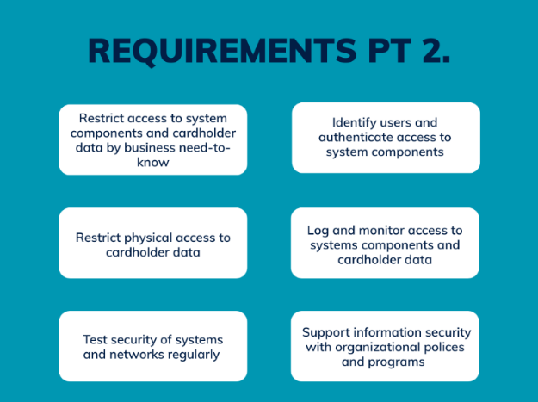
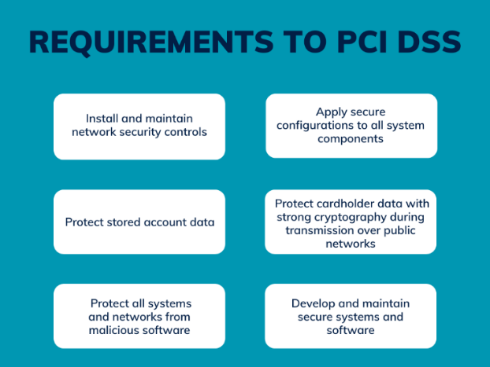

- Install and maintain network security controls: Implementing controls strengthen the network, increasing its security. If network is weak due to vulnerabilities, it is easy for the network to become compromised. A compromised network may expose customers’ financial data.
- Protect stored account data: Data at rest should be protected in case machines are compromised or stolen.
- Protect all systems and networks from malicious software: Personnel should not be able to download unapproved software. This helps protect the network from malware.
- Apply secure configurations to all system components: Hardening system components such as servers, applications, databases, cloud resources, etc. prevents them from becoming an entry point into the system.
- Protect cardholder data with encryption: Encryption makes data unreadable when data is in transit or at rest. In the event of a breach data found would be illegible without proper cryptographic keys.
- Develop and maintain secure systems and software: Develop security procedures and follow reputable frameworks (such as NIST). Keep systems and software updated and continuously monitor them.
- Restrict access to system components and cardholder data: Maintain a list of authorized personnel and assign privileges based on roles. Tracking who has access to what will increase overall security.
- Identify users and authenticate access to system components: Users must be identified and authenticated before accessing system components. Users will be granted access based on their permissions. That way there is a trail showing who accessed what.
- Restrict physical access to cardholder data: Limits the amount of people who can access data. Keep receipts in a locked container, lock cash registers, and secure online system. Document where keys are and who has those keys.
- Test security of systems and networks: Penetration testing is crucial to understanding if the implemented controls are working and are enough to protect the system.
- Log and monitor access to systems components and cardholder data: Logs provide details in the event of unauthorized access.
- Support information security with organizational policies and programs: Information Security will provide recommendations to make the system secure which in turn improves the security of transactions as well.

Regulations

Health Insurance Portability and Accountability Act (HIPPA)
HIPPA is a federal law that established protection for sensitive health information. Patients must give consent for their health information to be disclosed. Health Network Inc. is considered a “covered entity” according to HIPPA standards. As a covered entity you must ensure that private health information (PHI) remains confidential, integrity remains and is readily available.
According to ManageEngine there are 5 general rules that make a covered entity compliant with HIPPA. The first is to implement or update security policies and procedures. This can be done through Standard of Procedures, or emergency planning. Second is either to enter into or update business associate agreements. This agreement outlines what both parties are responsible regarding the data. If a third party misuses PHI that could lead to repercussion for Health Network Inc. if agreements are not outlined. The third is to update and implement privacy policies and procedures. Some websites have noticed that data enter can be used for other things like cookies. Health Network Inc. can modify that to their own needs and update their privacy policies. The fourth is updated HIPPA Privacy Notices. This can be done by having privacy noticed in building or a user agreement document on a website. The fifth recommendation is to conduct HIPPA Compliance Training. Training solidifies the other steps. Making sure they are followed and people within the company are aware of changes and can communicate that to end users. Overall goal is the protection of PHI.

Roles and Responsibilities

Identifying who is responsible for what aspects of the risk assessment is important to ensure each department knows what to work on and who to go to if they need information. Knowing who manages what allows conversations to be had about system security in a timely manner. The listed responsibilities are what each team/employee needs to either contribute or provide for the risk assessment.

Table 0: Roles and Responsibilities
Role | Responsibilities
Senior Management | Make final decisions based on risk assessment, presentations, reports, etc.
IT Management | Oversee technological affairs in company as well as communication needs.
System and Information Owners | Implement any changes to system that are identity as risks in the risk assessment. Work with risk management to ensure controls are in place and working as expected.
Functional Management | Functional management ensures that the business is running smoothly. Risk management and functional management must work together to ensure that the solutions drafted can be done in a way that supports the whole business.
Information Security (IS) Management | Security managers can update IT team about risk assessment as well as share knowledge about system security.
Security Awareness Trainers | Training gives staff a chance to examine their own behavior and identity themselves how they may be putting the company at risk.

Project Schedule

Below is a schedule for the risk assessment. At the end of the listed week there will be different deliverables. Project Part 5 (End of Week 16) is when the final risk management plan will be completed.

Project Part 1  End of Week 5 | Risk Management Plan Outline and Research  Create an outline of a risk management plan, complete some sections such as the introduction, scope etc.; research and summarize relevant compliance laws; and create a schedule. Submit a draft of your work.
Project Part 2  End of Week 8 | Risk Assessment Plan  Submit a draft of your risk assessment plan.
Project Part 3  End of Week 11 | Risk Mitigation Plan  Submit a draft of your risk mitigation plan.
Project Part 4  End of Week 13 | Business Impact Analysis (BIA) and Business Continuity Plan (BCP)  Submit a draft of your BIA and BCP.
Project Part 5  End of Week 16 | Final Risk Management Plan  Submit the final risk management plan for the class project.

Part 2 – Risk Assessment Plan

Purpose and Importance

The purpose of the assessment plan is to assess the risk of Health Network Inc. Health Network Inc. has known vulnerabilities found during a previous risk assessment. This risk assessment will build upon those foundational vulnerabilities, find, document, and mitigate new vulnerabilities that are found. According to Plass (2025) the following are defined as “risk: the likelihood that a loss will occur; threat “any activity that represents possible danger; vulnerability “a weakness found in the system; and a loss result in a compromise to business functions or assets” (slide 3).

Scope and Boundaries

The risk assessment will consider the previous risk assessment and build upon it. Health Network Inc.’s main products, infrastructure, data assets, and personnel are what will be assessed and are the range of this project. Some topics may overlap such as personnel and data assets. The scope and boundaries will not be changed to ensure accurate information and timeliness of the report.

Data Center Assets and Activities

Below is a list of Health Network Inc’s Assets. The list was derived from Chapter 1: Risk Management Fundamentals class lecture (slide 7).
Institutional knowledge: Knowledge personnel have about systems that are unique to their role in the company.
Cost of gaining a customer: The cost to Health Network Inc. is a customer stops using services.
Customer influence: Impact either negative, neutral, or positive of customers experience that is shared with others.
Reputation: Overall image of the company which is influenced by staff and customers
Future lost revenue: Any business that goes to competitors rather than Health Network Ince is a lost of revenue.
Computer systems: Servers, desktop PCs, phones, and computers
Network hardware: Routers, switches, firewalls
Software applications: Any that are installed on computer systems, HNet Pay, HNet Connect, HNetExchange (VPN)
Data: Any databases that are used, electronic payment data, doctor information (Addresses, Medical certificates, and Provider services)

Risk Identification

Identifying risk must be structured, a uniform process will make it easier to identify more persistent risks and documentation of those risks. The goal is to reduce risk to do that Health Network Inc. must get information about their risks. If risk is not identified in a similar manner Health Network Inc. may not have accurate information and implement a control that does not accurately address the needs of the risk. According to TimesPro (2025) risk identification is “a proactive process of pinpointing potential threats that could adversely affect a project’s progress or success” (para 3.). Risk identification goes over how to find a threat through brainstorming and analyzing the circumstances of the risk assessment.
Step 1 in the process to identify risk is to look over any documentation (TimesPro, 2025). Project documentation must be reviewed which would include any contracts or plans related to the project. This ensures that all parties are aware of the scope of the project, goals and deliverables. Step 2 is Brainstorm. According to TimesPro (2025) Brainstorming is necessary to get a team involved and to “leverage collective knowledge and experience” (para. 15). Step 3 is to consult with stakeholders. Step 4 suggests analyzing any existing data or assessments that would be useful for risk assessment. Working with what you already must provide background information. Step 5 is to “assess environment factors” through a process called environmental scanning (TimesPro, 2025). Step 5 looks at how resources are being used and their effect. Steps 6 and 7 go hand and hand. Step 6 categorizes the risk and 7 creates what TimesPro (2025) labels as a “risk register” to store risk (para. 20). All the steps are a way to streamline the process of identifying a risk so that all risks that are found do not get lost in communication and addressed properly.
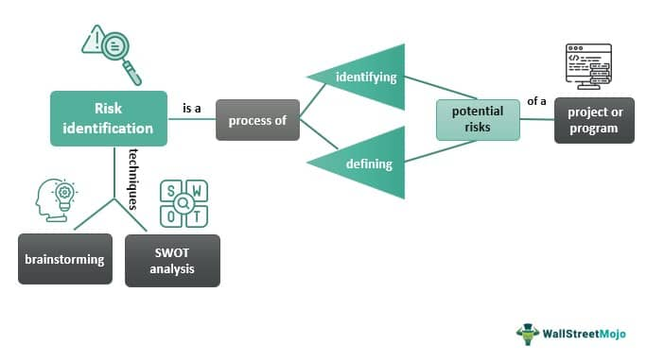

Figure 1: Risk identification diagram (Mehta, 2023)

Risk identification diagram illustrating key steps in risk management (Mehta, 2023)

Methods for Risk Identification

The following are techniques to be used during risk identification (TimesPro, 2025):
- Brainstorming: Open-ending process that involves free communication to get the opinions of employees
- Checklists: List all risks that come to mind. Tend to be ones that can be addressed quickly.
- Interviews: Hold interviews with experienced security professionals and project stakeholders
- SWOT (Strengths, Weaknesses, Opportunities and Threats): Look at project’s strength, weaknesses, possible opportunities, and threats that can help or harm the project.
- Delphi Technique: Company conducts several rounds of surveys to receive anonymous input from IT team or anyone that is involved with the risk assessment, including security professionals, to get a better understanding of persistent risks.
- Scenario Analysis: To think of a possible scenario that would impact the project. Risk assessment may take a long time depending on the size of the environment and scope. In case the risk assessment must be paused this technique helps those involved in the project think of ways to find a way to finish the project.
- Cause and Effect Analysis: Identifies root cause(s) of risks.

Threats and Vulnerabilities

Below is a list of threats found in Health Network Inc. A description is given to explain the threat and why it is considered a threat to Health Network Inc. The threats are linked to loss, unknown information, internal process, and personnel.
Table 1: List of Threats and Descriptions
Threat Identified | Description: Why is this considered a threat?
Loss institutional knowledge of IT processes | Once employees leave Health Network Inc. information is lost. Leaving a gap, current employees are underprepared to take over
Loss of company data due to hardware being removed from production systems: | Data is information that has potential value to achieve future and current business objectives. Without data it is harder for Health Network Inc to steer future investments.
Loss of company information on lost or stolen company-owned assets, such as mobile devices and laptops: | Loss of assets opens the door for unauthorized access to company data and systems. If someone can get the machine and log in, company information can be deleted, changed, and lost.
Loss of customers due to production outages caused by various events, such as natural disasters, change management, unstable software, and so on: | Inconsistency in service will break down customer trust leading to the loss of customers. Loss of customers affect Health Network Inc.’s reputation, profits, and image.
Unknown number of assets | Unknown number of assets (i.e. phones) impacts the Business Continuity Plan (cannot plan efficiently in case of an emergency if resources are not counted)
Unknown information on assets | No way to track and disable devices if lost or stolen
Internet threats due to company products being accessible on the Internet | Adversaries have the tools and time to exploit commonly found vulnerabilities in Health Network Inc. system and search for unknown vulnerabilities to exploit.
Changes in regulatory landscape that may impact operations | Health Network Inc. could be found not to be in compliance with regulations. Resulting in fines, legal action, and or loss of business function (i.e. ability to process credit cards)
Not authenticating users at sign in level | Adversaries can crack weak passwords gaining access to Health Network Inc. System
Privilege escalation internally | When privileges are not managed, unauthorized access is given, and unauthorized changes can happen
Phishing email attempts (forwarding attack, impersonation, etc.) | Constant phishing attempts comprise the systems security
Unauthorized access into Health Network Inc. buildings | Unauthorized physical access can lead to a loss of assets, data, and potential bring all the systems down

Risk Analysis

All risks identified will be assigned within a range. Risks will be prioritized by their level of importance. The probability of a risk being exploited and the severity of exploitation is what determine the range. The manager of the project assessment will determine the total risk (i.e. probability x severity). The definitions of what determines risk are found below.

Qualitative Risk Analysis

Evaluating risk qualitatively considers descriptive information about risk. Rather than quantify the risk through numeric value, which can sometimes be more difficult. Qualitative risk analysis allows Health Network Inc. to get a deep understanding of what is the likelihood a risk will happen and what will be the severity of exploitation. Qualitative risk analysis relies on “experts’ opinion, probability, and impact” (Lumivero, 2025).
Probability
- High (3) – 60% chance or higher
- Medium (2) – 30 to 50% percent chance of occurrence
- Low (1) – 20% percent chance of occurrence
Probability
Severity
 |  | L | M | H
Severity | L | 1 | 2 | 3
Severity | M | 2 | 4 | 6
Severity | H | 3 | 6 | 9
- High (3) – Risk has a high impact due to its value in Health Network Inc.
- Medium (2) – Risk could impact Health Network Inc. but not it would not severely effect its operations
- Low (1) – Risk that has a small impact on business functions

Probability x Severity = Total Risk
Risk level is low if: total risk ≥ 2
Risk level is medium if: 3 ≤ total risk < 6
Risk level is high if: total risk ≥ 6

Table 2: Risk Level
Threat Identified | Probability Level | Severity Level | Risk Level
Loss institutional knowledge of IT processes | High | Low | 3
Loss of company data due to hardware being removed from production systems | High | High | 9
Loss of company information on lost or stolen company-owned assets, such as mobile devices and laptops | Medium | Medium | 4
Loss of customers due to production outages caused by various events | Medium | Medium | 4
Unknown number of assets | Medium | Low | 2
Unknown information on assets | High | High | 9
Internet threats due to company products being accessible on the Internet | High | High | 9
Changes in regulatory landscape that may impact operations | Low | Low | 1
Not authenticating users at sign in level | Medium | High | 6
Privilege escalation internally (Insider threats) | Medium | High | 6
Phishing email attempts (forwarding attack, impersonation, etc.) | High | High | 9
Unauthorized access into Health Network Inc. buildings | Low | High | 3

Quantitative Risk Analysis

Health Network Inc. elected to do a qualitative risk assessment.

Risk Response Planning

The first step to responding to a risk is to plan. Who is responsible for making sure the risks are managed and what will they do to ensure that the plan is implemented and monitored? A risk owner would take responsibility for the implementation of the mitigation strategy. Health Network Inc. can avoid, mitigate, accept, place it on contingencies, or transfer a risk. All are strategies to limit risk. Certain risks, however, must be accept due to the inherent nature of the risk. Health Network Inc. would not aim to eliminate those risks but to limit the probability of exploitation.

Table 3: High Risk Response Plan
Threat | Risk Owner | Approach | Mitigation Strategy
Loss of company data due to hardware being removed from production systems | IT Management | Contingency | Create a policy and procedure that outlines the proper way to recycle hardware that is not in use.
Unknown information on assets | System and Information Owners | Mitigate | Perform an asset inventory annually
Internet threats due to company products being accessible on the Internet | Information Security Management | Accept | Products have to accessible online
Not authenticating users at sign in level | Information Security Management | Mitigate | Implement a multi authentication application on all devices
Loss of company-owned assets due to them being lost or stolen | System and information owners | Mitigate | Implement control on all devices that gives admin the ability to remotely disable any device
Privilege escalation internally (Insider threats) | System and information owners | Transfer | Buy a tool that analyzes logs about employee behavior. Notifies SIO if unusual behavior is detected.
Phishing email attempts (forwarding attack, impersonation, etc.) | Information Security Management | Transfer | Buy a tool that put unusual emails in a sandbox before sending them directly to employees

Table 4: Medium Risk Response Plan
Threat | Risk Owner | Approach | Mitigation Strategy
Loss institutional knowledge of IT processes | IT Management | Contingency | Encourage employees to train each other and rotate job roles
Loss of company information on lost or stolen company-owned assets | Senior Management | Transfer | Consult with legal team
Loss of customers due to production outages caused by various events | Functional Management | Mitigate | Release a statement to consumers apologizing and assuring them Health Network Inc. capabilities to provide great service
Unauthorized access into Health Network Inc. buildings | Information Security Management | Mitigate | Install badge readers on high-risk rooms

Controls

A recommended control for Health Network Inc. is to follow NIST 800-53. NIST 800-53 breaks down controls into twenty “families”. All are topics that have specific controls that will help Health Network Inc. build a more secure system. According to NIST (2020) there are “three ways to implement a control: a common control implementation approach (inheritable), a system-specific control implementation approach, and a hybrid control implementation approach” (Chapter 2, p. 11). Depending on the needs of Health Network Inc. customizing the implementation may be necessary to ensure best practice.
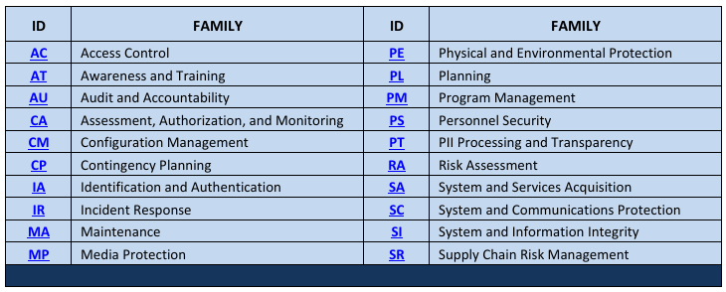
Figure 2: Security and Privacy Control Families (NIST, 2020)

Table 5: High Risk Threats and Proposed Controls
Threat | Approach | Control | How will this help?
Loss of company data due to hardware being removed from production systems | Contingency | SR-12 Component Disposal | Ensure that hardware is properly disposed
Unknown information on assets (e.g. location, operating system, storage) | Mitigate | CM-08 System Component Inventory | Ensure device is map to a location or person and has geographic software to track its location
Internet threats due to company products being accessible on the Internet | Accept | CA-07 Continuous Monitoring | Detect threats and respond once necessary
Not authenticating users at sign in level | Mitigate | IA-02 (organization users)  IA-03(non-organization users) | Password and second authentication for employees and users
Loss of company-owned assets due to them being lost or stolen | Mitigate | AC-08 System use notification  AC-11 device lock | Combination of banner and lock
Privilege escalation internally (Insider threats) | Transfer | AC-06 Least Privilege | Ensure users can do tasks without giving them unnecessary credentials
Phishing email attempts (forwarding attack, impersonation, etc.) | Transfer | SI-08 Spam protection | Implement spam software that detect spam coming in and going out.

Table 6: Medium Threats and Proposed Controls
Threat | Approach | Control | How will this help?
Loss institutional knowledge of IT processes | Contingency | PS-4 Personnel Termination  PS-5 Personnel Transfer | Retain information from employees’ files so it can be analyzed
Loss of company information on lost or stolen company-owned assets | Transfer | CP-09 System Backup | Backups will prevent data from being lost even if asset is gone
Loss of customers due to production outages caused by various events | Mitigate | CP-02 Contingency Planning | Setting up a contingency plan will ensure that core services will be function within a set amount of time
Unauthorized access into Health Network Inc. buildings | Mitigate | AC-08 Access Enforcement | Access will be limited based on set controls and authorization

Roles and Responsibilities

Below is a list of roles and responsibilities. Now that a risk response plan has been developed, responsible parties can now provide feedback on recommendations. As well as communicate if there are any conflicts with implementation. Reviewing the roles and responsibilities should also be used for communication purposes.

Table 0: Roles and responsibilities
Role | Responsibilities
Senior Management | Make final decisions based on risk assessment, presentations, reports, etc.
IT Management | Oversee technological affairs in company as well as communication needs.
System and Information Owners | Implement any changes to system that are identity as risks in the risk assessment. Work with risk management to ensure controls are in place and working as expected.
Functional Management | Functional management ensures that the business is running smoothly. Risk management and functional management must work together to ensure that the solutions drafted can be done in a way that supports the whole business.
Information Security (IS) Management | Security managers can update IT team about risk assessment as well as share knowledge about system security.
Security Awareness Trainers | Training gives staff a chance to examine their own behavior and identity themselves how they may be putting the company at risk.

Schedule

Part 1 and 2 of the risk assessment are now completed. Health Network Inc. will review the deliverables thus far and submit feedback before part 3 deadline. Project Part 5 (End of Week 16) is when the final risk management plan will be completed.

Project Part 1  End of Week 5 | Risk Management Plan Outline and Research  Create an outline of a risk management plan, complete some sections such as the introduction, scope etc.; research and summarize relevant compliance laws; and create a schedule. Submit a draft of your work.
Project Part 2  End of Week 8 | Risk Assessment Plan  Submit a draft of your risk assessment plan.
Project Part 3  End of Week 11 | Risk Mitigation Plan  Submit a draft of your risk mitigation plan.
Project Part 4  End of Week 13 | Business Impact Analysis (BIA) and Business Continuity Plan (BCP)  Submit a draft of your BIA and BCP.
Project Part 5  End of Week 16 | Final Risk Management Plan  Submit the final risk management plan for the class project.

Part 3 – Risk Mitigation Plan

Introduction

A risk mitigation plan finds the vulnerabilities of a system, considers the possible impact of exploitation (probability and severity) and then outlines how to mitigate the risks. All departments in Health Network Inc. will play an active role in the risk assessment by providing feedback and working with the risk assessment team to ensure that risks are accurately identified. The IT department supports the whole organization; however, they do not manage risks alone. That responsibly is shared with all employees at Health Network. Leveraging institutional knowledge about different departments will play a key role in ensuring that risks are identified accurately so they can be mitigated.

Purpose and Importance

The purpose of the assessment plan is to assess the risk of Health Network Inc. Health Network Inc. has known vulnerabilities found during a previous risk assessment. Documenting the different steps of the risk assessment ensures that the information is retained for future assessments, mitigation of current threats, and possibly identification of future ones. The goal is to end the project will a more secure system than before.

Previously Identified Threats

The following charts are threats previously identified during the last risk assessment Health Network Inc. conducted.

Table 2a: Risk Level of Previously Identified Risks
Threat Identified | Probability Level | Severity Level | Risk Level
Changes in regulatory landscape that may impact operations | Low | Low | 1
Loss of company information on lost or stolen company-owned assets, such as mobile devices and laptops | Medium | Medium | 4
Loss of customers due to production outages caused by various events | Medium | Medium | 4
Privilege escalation internally (Insider threats) | Medium | High | 6
Internet threats due to company products being accessible on the Internet | High | High | 9
Loss of company data due to hardware being removed from production systems | High | High | 9

Newly Identified Threats

The table below are the new threats identified found in Health Network Inc. system.

Table 2b: Risk Level of Newly Identified Risks
Threat Identified | Probability Level | Severity Level | Risk Level
Unknown number of assets | Medium | Low | 2
Unauthorized access into Health Network Inc. buildings | Low | High | 3
Loss institutional knowledge of IT processes | High | Low | 3
Not authenticating users at sign in level | Medium | High | 6
Phishing email attempts (forwarding attack, impersonation, etc.) | High | High | 9
Unknown information on assets | High | High | 9

Controls to Implement

Below shows a table of both high and medium level threats and controls to mitigate them. Reviewing each risk and its control is important to fully understand what is causing the threat and how the root of that threat will be eliminated, mitigated, or monitored. Some threats are not meant to be solved but the goal is to limit the probability of exploitation.

Table 5: High Risk Threats and Proposed Controls
Threat | Approach | Control | How will this help?
Loss of company data due to hardware being removed from production systems | Contingency | SR-12 Component Disposal | Ensure that hardware is properly disposed
Unknown information on assets (e.g. location, operating system, storage) | Mitigate | CM-08 System Component Inventory | Ensure device is map to a location or person and has geographic software to track its location
Internet threats due to company products being accessible on the Internet | Accept | CA-07 Continuous Monitoring | Detect threats and respond once necessary
Not authenticating users at sign in level | Mitigate | IA-02 (organization users)  IA-03(non-organization users) | Password and second authentication for employees and users
Loss of company-owned assets due to them being lost or stolen | Mitigate | AC-08 System use notification  AC-11 device lock | Combination of banner and lock
Privilege escalation internally (Insider threats) | Transfer | AC-06 Least Privilege | Ensure users can do tasks without giving them unnecessary credentials
Phishing email attempts (forwarding attack, impersonation, etc.) | Transfer | SI-08 Spam protection | Implement spam software that detect spam coming in and going out.

Table 6: Medium Threats and Proposed Controls
Threat | Approach | Control | How will this help?
Loss institutional knowledge of IT processes | Contingency | PS-4 Personnel Termination  PS-5 Personnel Transfer | Retain information from employees’ files so it can be analyzed
Loss of company information on lost or stolen company-owned assets | Transfer | CP-09 System Backup | Backups will prevent data from being lost even if asset is gone
Loss of customers due to production outages caused by various events | Mitigate | CP-02 Contingency Planning | Setting up a contingency plan will ensure that core services will be function within a set amount of time
Unauthorized access into Health Network Inc. buildings | Mitigate | AC-08 Access Enforcement | Access will be limited based on set controls and authorization
Table 6: Medium Threats and Proposed Controls

Future Threats

Once the risk assessment is completed it is already considered “out of date” the minute something changes in the system. New threats will become present because of those changes and must be mitigated. The IT department will need to continuously monitor Health Network Inc. system and ensure that new technological standards are met to improve security of the system. Quantum computing, for example, could have the power to break modern cryptography. Due to the “public key” method that relies on the difficulty of modular arithmetic when sending keys over an open channel. Another threat to Health Network Inc could be cyber-attacks that expose people’s private health information. Considering that Health Network Inc. is a health care company and holds private data about its patients, it is important that they secure their data and any third-party that processes it such as cloud providers. Cloud providers themselves can be a threat since they do experience outages. Having a contingency plan that outlines a backup if a core provider is impacted by an outage will be important for Health Network Inc. to remain operational during an outage.
Table 7: Future threats and descriptions
Future Threats | Descriptions
Quantum computing | Quantum computing could possibly break encryption schemes implemented (DH key exchange)
Health Network Inc. dependence on cloud providers for redundancy | Mass outage can disrupt cloud providers. Their availability may be crucial to the functions of Health Network Inc. Health Network Inc. must diversify backup options.
Reliance on automated software and Artificial Intelligence | In case those services are not available does personnel know how to perform role without tools
Complex Cyberattacks | Advance Persistent Threat has unlimited resources and may have an interest in attacking Health Network Inc.
Pandemic | Pandemics may change the way Health Network Inc. can function and how their customers interact with the products.

Part 4 – Business Impact Analysis (BIA) & Business Continuity Plan (BCP)

Business Impact Analysis

Purpose

A business impact analysis researches what effects a business. Health Network Inc. goal is to remain operational to serve its clients. For that to happen Health Network Inc. must understand its own process and operations.

Mission/Business Processes and Recovery Criticality
    - Mission/business processes supported by the system are identified and the impact of a system disruption to those processes is determined along with outage impacts and estimated downtime. The downtime should reflect the maximum that an organization can tolerate while still maintaining the mission.

Resource Requirement
    - Realistic recovery efforts require a thorough evaluation of the resources required to resume mission/business processes and related interdependencies as quickly as possible. Examples of resources that should be identified include facilities, personnel, equipment, software, data files, system components, and vital records.

Recovery Priorities
    - Based upon the results from the previous activities, system resources can more clearly be linked to critical mission/business processes. Priority levels can be established for sequencing recovery activities and resources.

System Descriptions
Health Network Inc. system architecture is defined to gain an understanding of what the weak points in the system are. The diagram below shows the architecture of Health Network Inc. The customers of Health Network Inc. are in the United States of America primary around three states: Minnesota, Oregon, and Virginia. The location in Arlington, Virginia is the primary location for the following departments, Finance, Legal and Customer Support. Virgina is on the east coast and is affected by winter’s storms. Personnel often are delayed in getting to the office because of the storm. Each location has a co-location data center to back up their system. If one location experiences an outage a co-location data center will have a backup of the data. The Headquarters data center should be backing up three systems.
Diagram 1: Architecture of Health Network Inc.
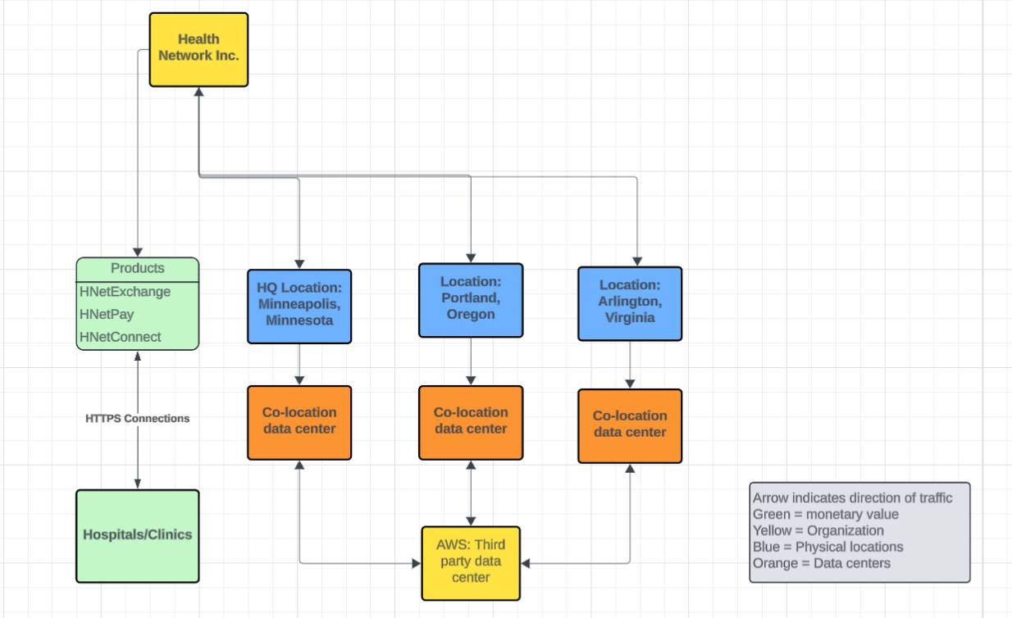
Physical locations:
Headquarters: Minneapolis, Minnesota
Location 1: Portland, Oregon CO-Location data center: Oregon (Border the water)
Location 2: Arlington, Virginia CO-Location data center: Virginia (Borders the water)
General location of CUSTOMERS: Hospitals and clinics, United States (Oregon, Virgina, and Minnesota)

Determine Process and System Criticality
Determining process and system criticality is beneficial to identify what Health Network Inc. functions are. Listing out critical business functions makes it possible to plan if those functions are disrupted. Input from process owners, managers, users and points of contact (internal and external) was given to create this list of processes. Health Network Inc.’s goal is to understand what makes the organization run and who is involved in those processes to plan in event of an outage or disruption of any sort.
Table 8: Business Critical Functions
Mission/Business Process | Description
Arlington Location | Primary location for financial, legal, and customer support operations
Integrity of data on applications | If data is tampered with incorrect business decisions may be made as well as health decisions
Network Security: HTTPS connection for all products | HTTPS connection must be secure to ensure endpoints are not being exposed to malicious content
Secure channel: HNetExchange | Message exchange between Providers and Patients must be secure. Avoid man-in-the middle attacks, and unauthorized disclosures.
Compliance with regulations: HIPPA, PCI DSS | Legal implication if Health Network Inc. is not following regulations
Data center operations | Data center holds company backups in case of an outage
Customer Support Operations (Organization wide) | Must be able to reach out to customers and vice versa to ensure products are working for them

Outage Impacts
The following impact categories represent key areas for consideration in the event of disruption or impact. Each category affects Health Network Inc. continuity plan. An outage can result in penalties, unforeseen costs, and damage to Health Network Inc.’s reputation.
Table 9: Outage Impact Categories
Category | Impact Level | Description
Cost to Health Network Inc. | Severe | >$5,000,000 spent in remediation
Cost to Health Network Inc. | Moderate | ≥$1,000,000 spent in remediation
Cost to Health Network Inc. | Minimal | < $999,999 spent in remediation
Damage Reputation | Severe | Loss of 50% of customers, 500 negative customer reviews
Damage Reputation | Moderate | Loss of 20% of customers, 100 negative customer reviews
Damage Reputation | Minimal | Loss of 10% of customers, 50 negative customer reviews
Regulatory Fine | Severe | $250,000 fines or more
Regulatory Fine | Moderate | $100,000 fines or less
Regulatory Fine | Minimal | $10,000 fines or less

The table below summarizes the impact on each mission/business process if Health Network Inc. system were unavailable, based on the following criteria:
Table 10: Analysis of Business-Critical Processes in event of an outage

Mission/Business Process | Impact Category
Mission/Business Process | Cost | Reputational Damage | Regulatory Fine
Arlington Location | Severe | Severe | Moderate
Accurate representation of information on products | Minimal | Severe | Minimal
Network Security: HTTPS connection for all products | Moderate | Moderate | Moderate
Secure channel: HNetExchange | Moderate | Severe | Severe
Data center operations | Severe | Moderate | Minimal
Customer Support Operations | Minimal | Severe | Minimal

Estimated Downtime

Providing an estimate of downtime not only gives Health Network Inc. an idea of how long a risk could cause a resource to be down but also how long a resource can be down before it impacts other resources, and operations.
- Maximum Tolerable Downtime (MTD). The MTD represents the total amount of time leaders/managers are willing to accept for a mission/business process outage or disruption and includes all impact considerations. Determining MTD is important because it could leave continuity planners with imprecise direction on (1) selection of an appropriate recovery method, and (2) the depth of detail which will be required when developing recovery procedures, including their scope and content.
- Recovery Time Objective (RTO). RTO defines the maximum amount of time that a system resource can remain unavailable before there is an unacceptable impact on other system resources, supported mission/business processes, and the MTD. Determining the information system resource RTO is important for selecting appropriate technologies that are best suited for meeting the MTD.
- Recovery Point Objective (RPO). The RPO represents the point in time, prior to a disruption or system outage, to which mission/business process data must be recovered (given the most recent backup copy of the data) after an outage.
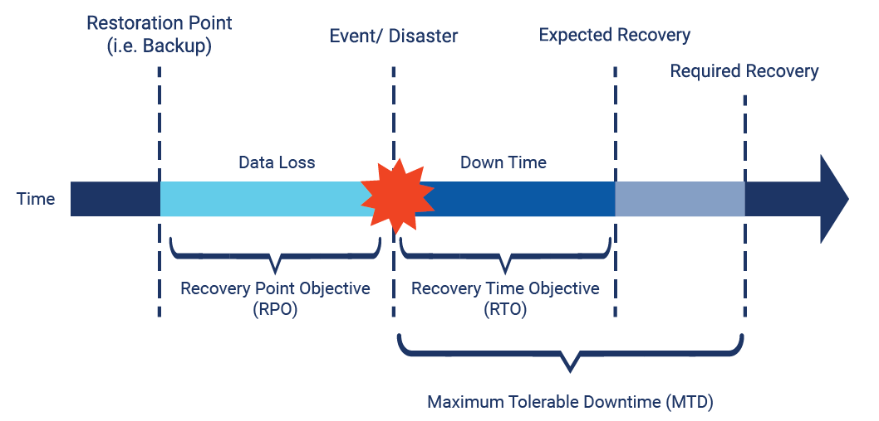
Figure 3: Defining RPO, RTO, and MTD (Hron, 2020)

The table below identifies the MTD, RTO, and RPO (as applicable) for the organizational mission/business processes that rely on Health Network Inc.
Table 10: Downtime for each Business-Critical Function
Mission/Business Process | MTD | RTO | RPO
Arlington Location | 48 hours | 20 hours | 10 hours
Integrity of data on applications | 30 hours | 15 hours | 5 hours
Network Security: HTTPS connections for all products | 30 hours | 15 hours | 5 hours
Secure channel: HNetExchange | 30 hours | 15 hours | 5 hours
Data center operations | 48 hours | 20 hours | 20 hours
Customer Support Operations (Organization wide) | 30 hours | 15 hours | 5 hours

Identify Resource Requirements
The following table identifies the resources that compose Health Network Inc. system including hardware, software, and other resources such as data files.
Table 11: System Resource
System Resource/Component | Platform/OS/Version | Description
Servers | Linux | Host Health Network Inc. products
Laptops | Windows 11 | Personnel assets
Mobile devices | IOS | Personnel assets
Routers | Cisco IOS | Routes traffic between different networks.
Firewalls | Linux | Hardware between internet and servers. Protect servers from internet.
Database 1 | MySQL | Holds data about products and updated information about clinical staff

Identify Recovery Priorities for System Resources
The table below lists the order of recovery for Health Network Inc. resources. The table also identifies the expected time for recovering the resource following a “worst case” (complete rebuild/repair or replacement) disruption.
Recovery Time Objective (RTO) - RTO defines the maximum amount of time that a system resource can remain unavailable before there is an unacceptable impact on other system resources, supported mission/business processes, and the MTD. Determining the information system resource RTO is important for selecting appropriate technologies that are best suited for meeting the MTD.

Table 12: Recovery Time for System Resource
System Resource/Component | Recovery Time Objective (RTO)
Servers | 3 hours
Laptops | 20 hours
Mobile devices | 20 hours
Routers | 3 hours
Firewalls | 1 hour
Database 1 | 1 hour

Business Continuity Plan (BCP)

Overview

Scope

According to IBM a business continuity plan “refers to an organization’s ability to maintain critical business functions, minimize disruptions and resume normal business operations with minimal downtime when a crisis happens” (Para. 1). The scope of this business continuity plan is Health Network Inc. (whole organization) and the third-party data centers (three locations).

Key Business Areas

Key Business Areas are specific departments that play an integral role in the operations of the organization. In the event of an incident taking place these departments will create the stability of the organization. Ensuring it remains operational.
Health Network Inc.’s Key Business Areas are:
- HR
- IT
- Information Security
- Legal
- Finance

Critical Functions

Below are the critical functions of Health Network Inc. and their descriptions.

Table 8: Business Critical Functions
Mission/Business Process | Description
Arlington Location | Primary location for financial, legal, and customer support operations
Integrity of data on applications | If data is tampered with incorrect business decisions may be made as well as health decisions
Network Security: HTTPS connection for all products | HTTPS connection must be secure to ensure endpoints are not being exposed to malicious content
Secure channel: HNetExchange | Message exchange between Providers and Patients must be secure. Avoid man-in-the middle attacks, and unauthorized disclosures.
Compliance with regulations: HIPPA, PCI DSS | Legal implication if Health Network Inc. is not following regulations
Data center operations | Data center holds company backups in case of an outage
Customer Support Operations | Must be able to reach out to customers and vice versa to ensure products are working for them

Acceptable Downtime

Below are the Maximum Tolerant Downtime MTD time frames for each Business-Critical Function.
Table 13: Maximum Tolerant Downtime
Mission/Business Process | MTD
Arlington Location (Primary location for three departments) | Finance: 48 hours  Legal: 48 hours  Customer Support: 4-6 hours
Integrity of data on applications | 30 hours – People are making decisions based on data
Network Security: HTTPS connections for all products | 30 hours
Secure channel: HNetExchange | 30 hours
Data center operations | 48 hours
Customer Support Operations (Organization wide) | 30 hours

Plan to Maintain Operations

Notification:

For Health Network Inc. to maintain operational during an outage all employees must be notified. A group of designated personnel on the IT team will be given an essential role. They will ship out any assets to personnel in case of a long-term delay that prevents people from coming into the office. Such as in the case of a pandemic. All managers will need to keep a copy of the Business Continuity Plan (BCP) and Business Impact Analysis (BIA) at home. A call tree will need to be created to ensure that communication is flawless between staff. Ensuring everyone receives the same message. An automated system will call employees with instructions and updates. Detailed instructions will be issued by department managers using the call tree. Communication with clients (Health Network Inc and client companies) will be company to company. No sole person will oversee communication. Notifying clients will be on behalf of Health Network Inc. Organization email should be used or another form of communication.
Operations:

Majority of personnel will work from home if the incident requires. Essential staff will support the people who are working from home. As an example, essential staff from the IT department will ship out assets needed to the rest of organization who are working from home and make sure all local servers are up and running. A contingency site must be identified if one or more of the data centers is down. That way the data can roll over in case of one or more being done.

Roles and Responsibilities

Who needs to do what is an essential part of continuity planning. It ensures that roles are defined in case the plan is enacted. Below are the listed roles and responsibilities to ensure that downtime is minimal (in the context of an event happening).
Table 14: Roles and Responsibilities during an Incident
Roles | Responsibilities
Essential Staff in Each Department | Support their designated department to make sure they can remain operational while outage is happening
Managers | Develop a plan for employees to work remotely and communicate expectations
IT Department/ Security teams | Monitor system remotely, make sure staff are following policy and procedures, support business applications
Incident Management Team: HR directors, Legal Team, IT, and senior leadership | Handle all incidents, identify why is the system not working

Incident Management Team

The Incident Management Team should be a group consisting of senior leadership, Legal, Human Resources, and the IT department. Senior Leadership have the final say in what Health Network Inc. decides to do. Also, they may contribute valuable information if they are in communication with other companies in the industry who are experiencing the same type of event. Legal needs to be involved to advise senior leaders and to get into contact with law enforcement if necessary. HR responsibility stays the same. They must be able to manage any personnel related tasks as normal. The IT department monitors Health Network Inc system and support business applications, and all departments in Health Network Inc.

Emergency Communications

Communication during an emergency needs to be detailed, instructional, and most importantly timely. An automated call system has the capabilities to alert people fast. The system will pull all numbers from the call tree. Additional communication may take place among teams to ensure that all personnel are aware of incident and are given instructions on what to do.

Customer Communications

Health Network Inc. will contact clients who are directly impacted by the outage and issue a general statement about impact on social media platforms, as well as send emails out to clients. The emails should point customers to resources where they can report any issues they are experiencing.

Staff Communications

Staff will leverage communication through teams, emails, and video calls. As well as department distribution that they communicate through. During an outage it is just as important for there to be communication between staff. That way staff can adjust and know what is happening within the organization. Staff may have unique insight into what they see in their end. Which can be useful information to manage the outage or managing operations during an outage.

Incident Response Procedures

Incident Response Procedures will help Health Network Inc. before, during, and after an incident. When responding to an incident Health Network Inc. should follow steps to stay organized. According to Cranford uses NIST defines the steps as shown in the chart below. SANS, Cranford sites has a slightly different variations of steps but both show the important work that must be done before, during, and after an incident. Preparation can include training, putting call trees together, and implementing emergency communication software. Detection and Analysis can include continuous monitoring services. Containment, Eradication, and Recovery isolate the root cause of the risk, remove it, and bring up all services or data that were lost during the event. The last step which is a significant part of incident response is to review all the steps. What worked? What did not work? What can be done better in the future? Making it simple to update the business continuity plan and respond better during the next incident.
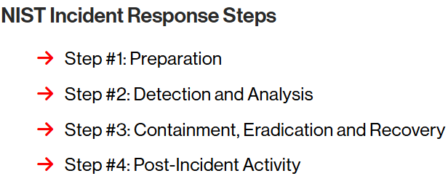
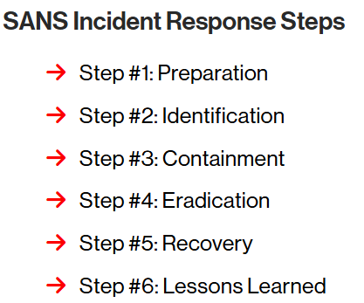

Figure 3: NIST Response Steps (Cranford, 2023)

Figure 4: SANS IR steps (Cranford, 2023)

References

1 Project Manager. (2024.). How to make a risk management plan (template included).
https://www.projectmanager.com/blog/risk-management-plan
2 Evotix. (2024). 7 benefits of conducting a risk assessment. Evotix. https://www.evotix.com/resources/blog/7-benefits-of-conducting-a-risk-assessment
3 Hancock, S. M. (2025). PCI DSS version 4.0.1 : a guide to the payment card industry data security standard ([First edition].). IT Governance Publishing Ltd.
4 Scrut Automation. (2025). 10 key healthcare IT security compliance standards and frameworks. Scrut. https://www.scrut.io/post/healthcare-cybersecurity-frameworks
5 Centers for Disease Control and Prevention. (2024, September 10). Health Insurance Portability and Accountability Act of 1996 (HIPAA). https://www.cdc.gov/phlp/php/resources/health-insurance-portability-and-accountability-act-of-1996-hipaa.html

6 ManageEngine. (n.d.). HIPAA compliance auditing and reporting | ADAudit Plus. ManageEngine. https://www.manageengine.com/products/active-directory-audit/hipaa-compliance-reporting-tool.html
7 Centers for Medicare & Medicaid Services. (2023). Federal Information Security Modernization Act (FISMA). U.S. Department of Health & Human Services. https://security.cms.gov/learn/federal-information-security-modernization-act‐fisma
8 GovDataHosting. (n.d.). What type of organization is subject to FISMA. GovDataHosting. https://www.govdatahosting.com/blog/what-type-organization-subject-fisma
9 Plass, M. (2025). Chapter 1: Risk Management Fundamentals [Class lecture]. Security Assessment and Risk Management, Lewis University Jones & Barlett

10 TimesPro. (2025, June 15). What is risk identification? Techniques, steps, and examples. Risk Identification 2025 Guide (Pros, Cons, Process & Techniques)
11 Mehta, K. (2023). Risk identification diagram [Image]. WallStreetMojo. Risk Identification - What Is It, Techniques, Examples, Advantages
12 Lumivero. (2025, June 16). An introduction to qualitative risk analysis: What it is, why it’s used, and how it works. Your guide to qualitative risk analysis for decision-making
13 National Institute of Standards and Technology (2020) Security and Privacy Controls for Information Systems and Organization. (U.S. Department of Commerce, Washington, D.C.), NIST Series (800-53) Rev. 5. https://doi.org/10.6028/NIST.SP.800-53r5
14 Horn, R. (2020, August 27). What is the difference between RPO, RTO, and MTD? What is the difference between RPO, RTO, and MTD? - Tandem
15 IBM. (n.d). What is business continuity? What Is Business Continuity? | IBM
16 Cranford, J. (2023, July 6). Incident Response Plan: Frameworks and Steps Incident Response Plan: Frameworks and Steps | CrowdStrike

